User Manual

for

ClubZen IITK

Version 1.0

Prepared by

Group 12 Group Name: Tiny Coders

|  |  |  |
| --- | --- | --- |
| Akash Biswas | 200074 | [abiswas20@iitk.ac.in](mailto:abiswas20@iitk.ac.in) |
| Avinash Prased | 200231 | [avinashp20@iitk.ac.in](mailto:avinashp20@iitk.ac.in) |
| Chandekar Vidish Vijay | 200291 | [cvvijay20@iitk.ac.in](mailto:cvvijay20@iitk.ac.in) |
| Harshit Gupta | 200429 | [guptah20@iitk.ac.in](mailto:guptah20@iitk.ac.in) |
| Jaya Meena | 200472 | [jayameena20@iitk.ac.in](mailto:jayameena20@iitk.ac.in) |
| Nikhil Verma | 200637 | [nikhilv20@iitk.ac.in](mailto:nikhilv20@iitk.ac.in) |
| Priyal Agrawal | 200730 | [priyalag20@iitk.ac.in](mailto:priyalag20@iitk.ac.in) |
| Priyanka Meena | 200731 | [priyankam20@iitk.ac.in](mailto:priyankam20@iitk.ac.in) |
| Shreyasi Mandal | 200956 | [shreyansi20@iitk.ac.in](mailto:shreyansi20@iitk.ac.in) |
| Vartika | 201089 | [vartikag20@iitk.ac.in](mailto:vartikag20@iitk.ac.in) |

|  |  |
| --- | --- |
| Course: | CS253 |
| Mentor TA: | Aishwarya Gupta |
| Date: | 04.04.2022 |

Content

# Introduction

**WORKING DOCUMENT WITH gifs**

<https://www.dropbox.com/scl/fi/h5byqkcllr808rh9hrjhx/UserManual_ClubZenIITK.docx?dl=0&rlkey=9qoi5hi1q9i0k39oo88tg4wuk>

**SOFTWARE OVERVIEW**

ClubZen IITK is a web application to integrate all the three Councils,i.e. Games and Sports Council, Media and Cultural Council, Academics and Career Council (their clubs and societies), and the three major fests (Antaragni, Udghosh, Techkriti ) in one place. It connects all the aspects of the institute’s co-curricular activities including workshops, meetings and social interaction.

Learning to use this software is easy.You should review the aforementioned document thoroughly before you make use of the application.This user guide presents an overview of the application’s features and gives step-by-step instructions for completing a variety of tasks.

**CLUBZEN DATABASE**

Clubzen uses the MondoDB to store data. MongoDB is an open-source document database and leading NoSQL database. MongoDB is a source-available cross-platform document-oriented database program. Classified as a NoSQL database program, MongoDB uses JSON-like documents with optional schemas.

**ADMIN MODE**

The ADMIN can add, remove or alter calendar information. Calender can be accessed by all but the editing can only be done by admin.

**USER MODE**

When you login with registered user account, you will enter to the profile page where your username, full name, email and authorities you currently holds will be displayed. Now all the pages will be accessible to the user.

# QuickStart Guide for Login and Registration

**LOGIN**

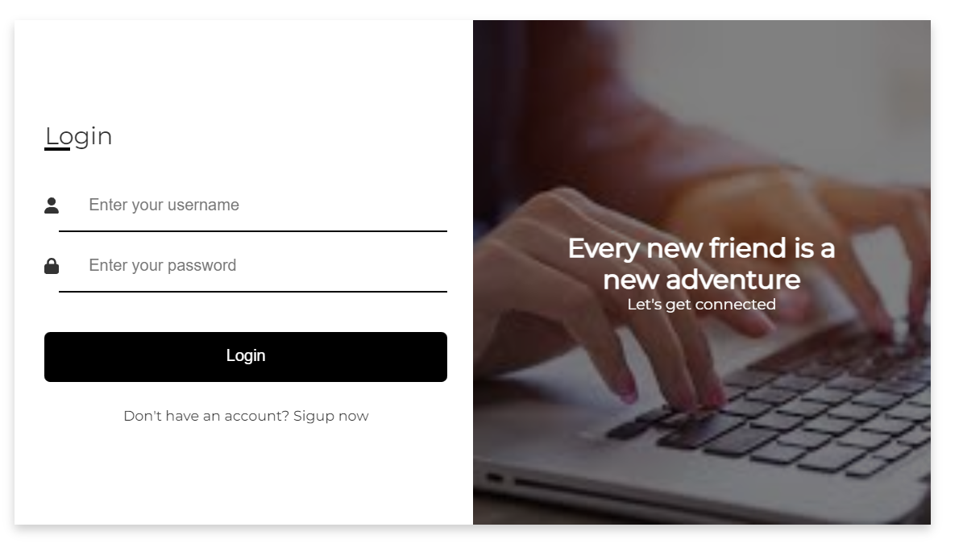

Users who have previously registered for the **ClubZen** Web Application must login by:

  - Entering their **Username**.

  - Entering their **Password.**

 Clicking on **Login** will advance to the **Profile** page and logged in users can begin using the application.

**Site Registration**

Users who have not previously registered for the **ClubZen** Web Application must select     “Don’t have an account? **Signup now**” to access the “New User Registration” page.



**REGISTER**

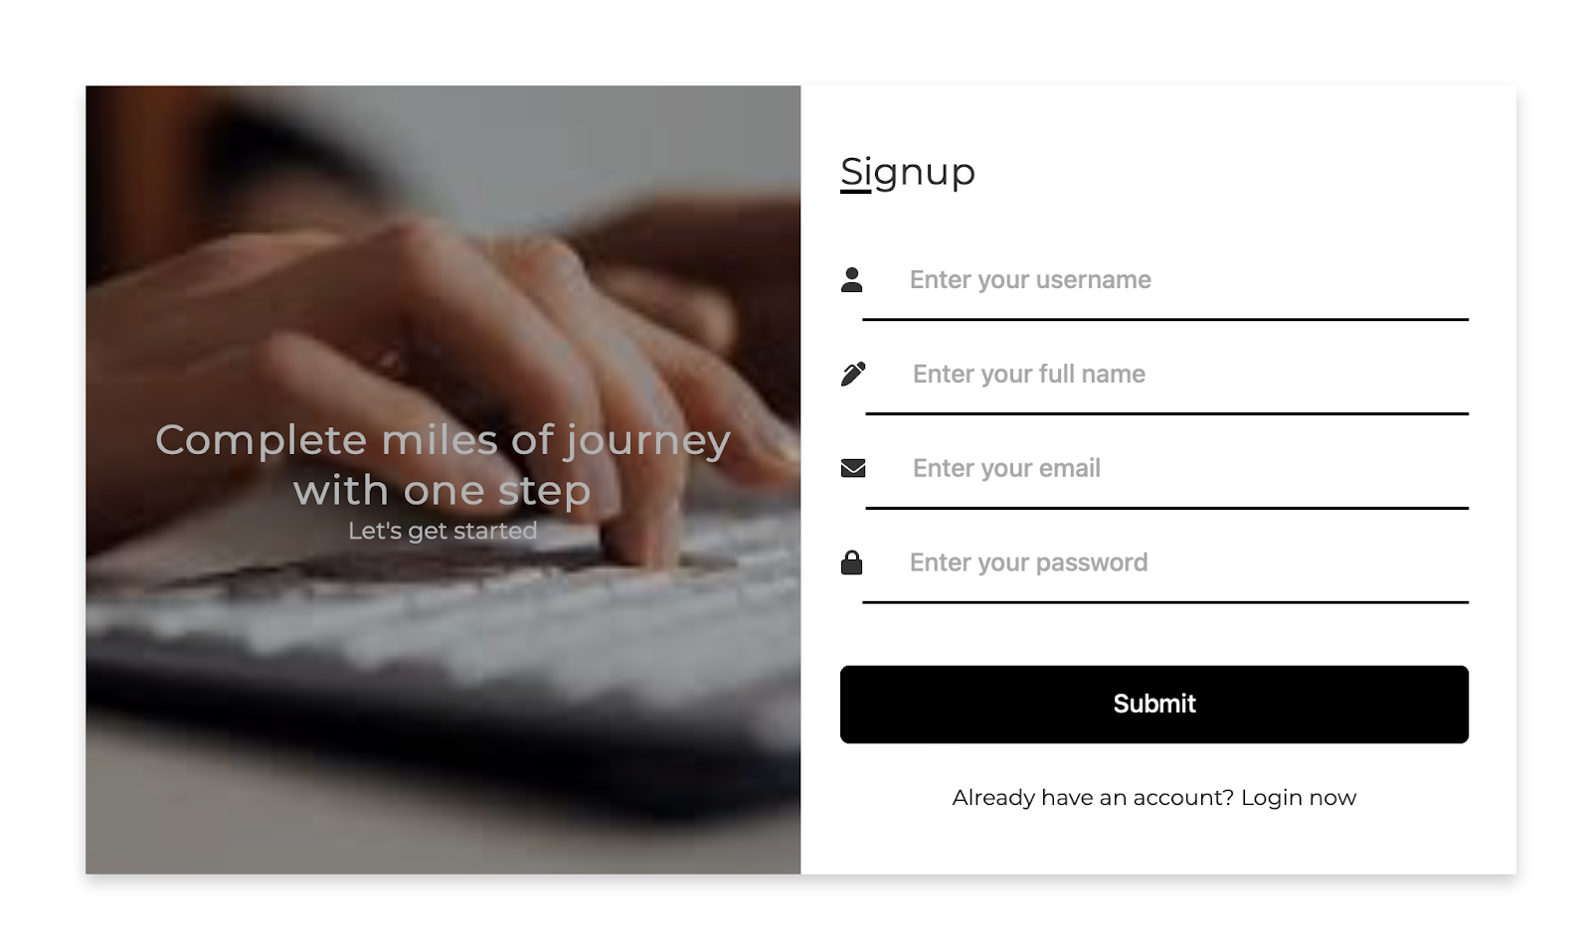

During the time of registration, users will be asked to enter following information -

- User Name : Each user is required to enter a unique username

- Full Name : Users must enter their full name

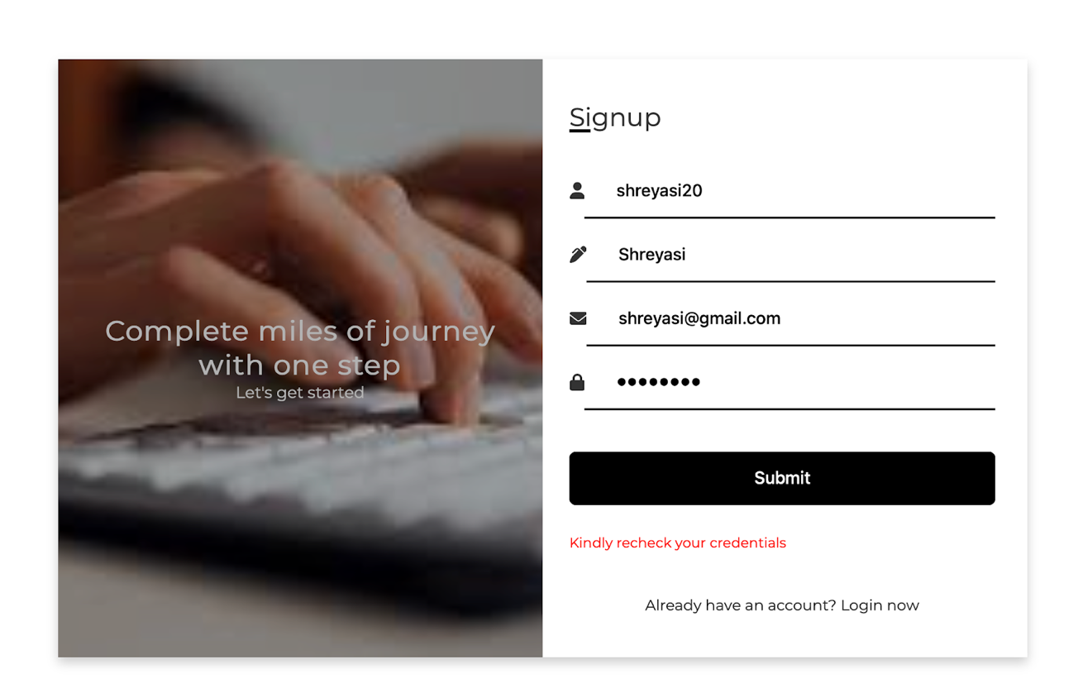

- Email : Users must enter their IITK email-id during the time of registration (this step was added to allow only IITK users to create account)

- Password : Users must enter a password. Passwords are case sensitive.

**PROFILE PAGE**

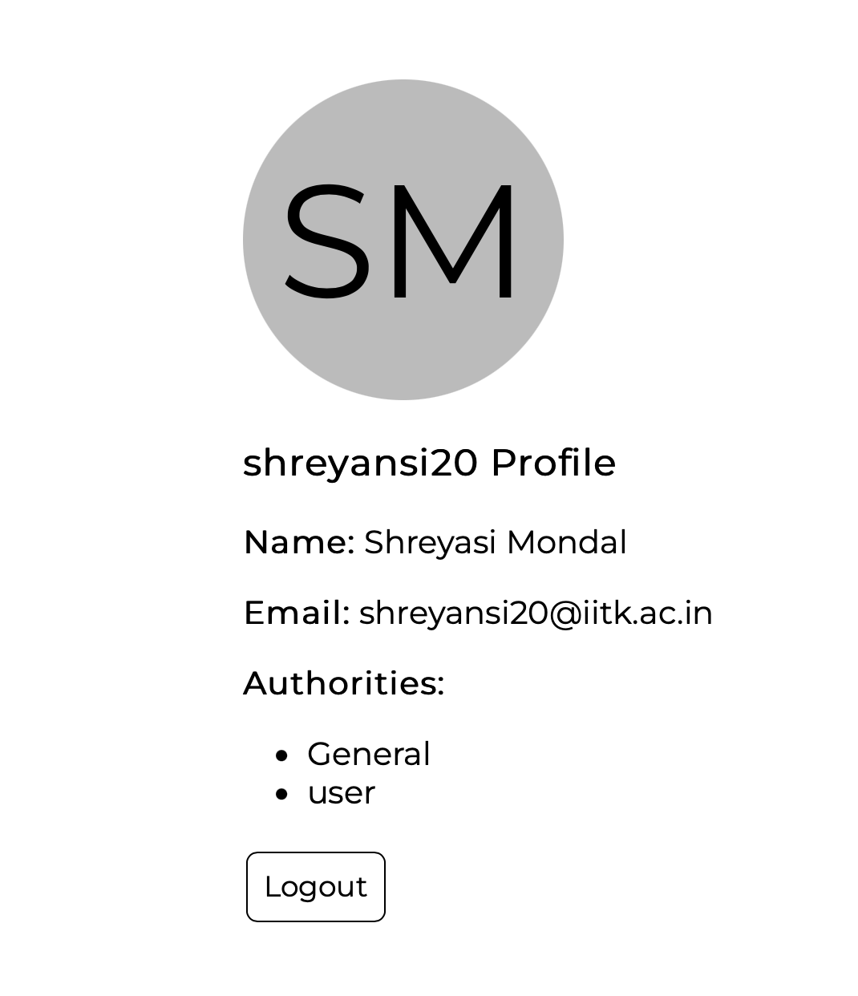

The **name initials** (filled during registration) were used to generate the default profile picture of the user.

The Profile of the user displays his/her username, fullname, email and authorities the user currently holds.

**Logout**

The users can click on the Logout button to logout from their account and navigate the web application as a guest user.

Doing this will redirect the user to the **Login** page.

Now, let’s see the above processes in action.



As seen from the above demo, upon successful signup or registration, the user is redirected to the Login page.

If the user is successfully logged in, he/she is taken to his/her profile page.  
On clicking Logout, the user is redirected to the Login page.

# Home Page

Home page is the main hub of ClubZen - IITK.

It shows information related to various activities happening around campus. From home page the users can navigate to the following pages:-

* Councils
* Festivals
* Clubs
* Calendar
* News and Events
* Profile

The image below shows how the Home Page looks like as a guest.

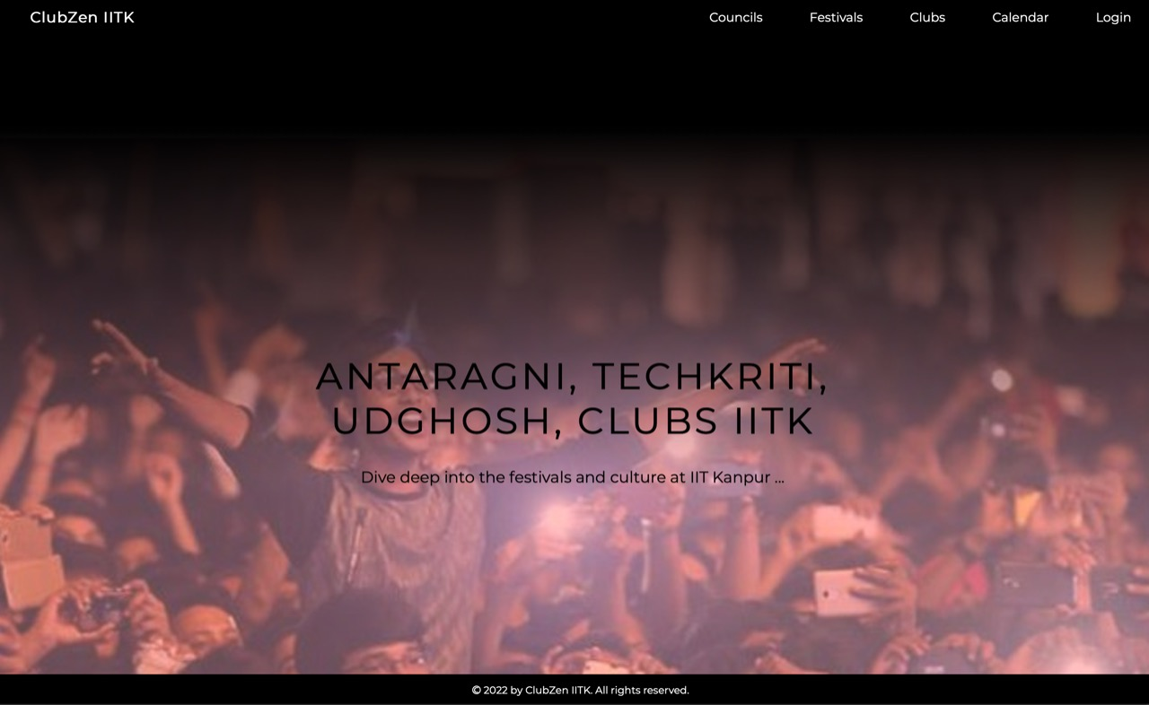

The image below shows how the Home Page looks like as a logged in User.

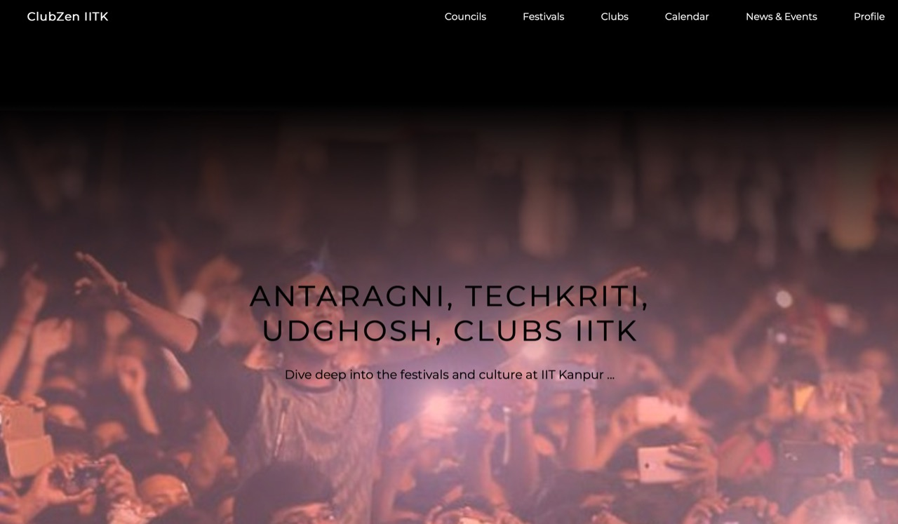

The top right corner has all the navigation options.

**Festivals Section**

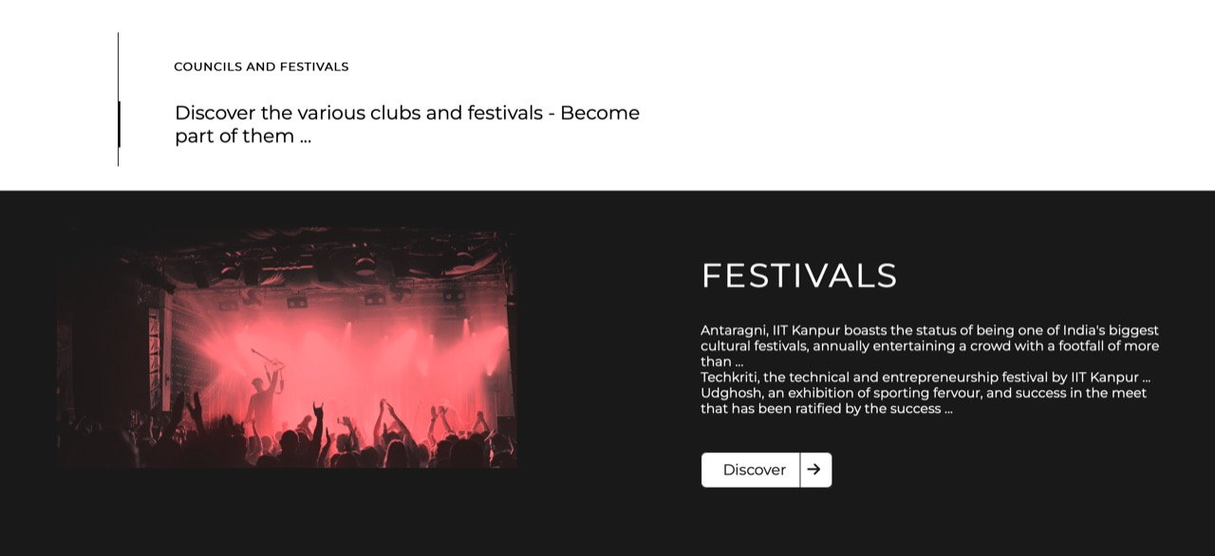

**Councils Section**

Scrolling down, users will have the option to explore festivals, councils and events.

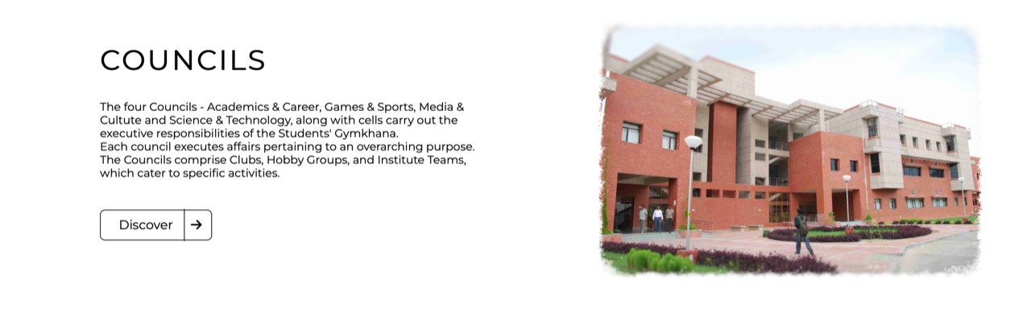

If the user is a guest, they can only view Festivals and Councils.

**Events Section**

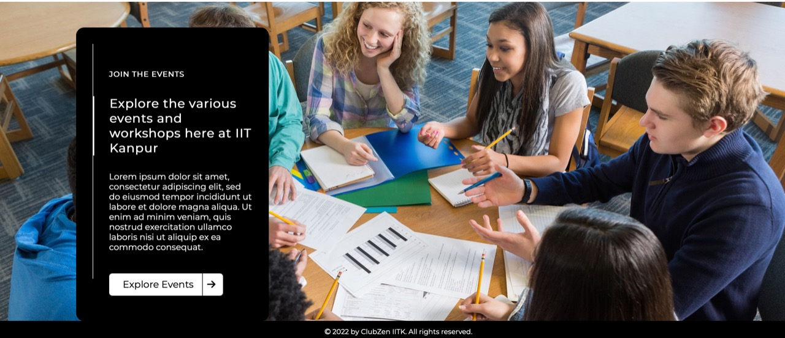

As a guest if the user tries to navigate to Explore Events they’ll be redirected to the login page.

As a logged in user, you can access Explore Events.

# Using the Calendar – Admin and User

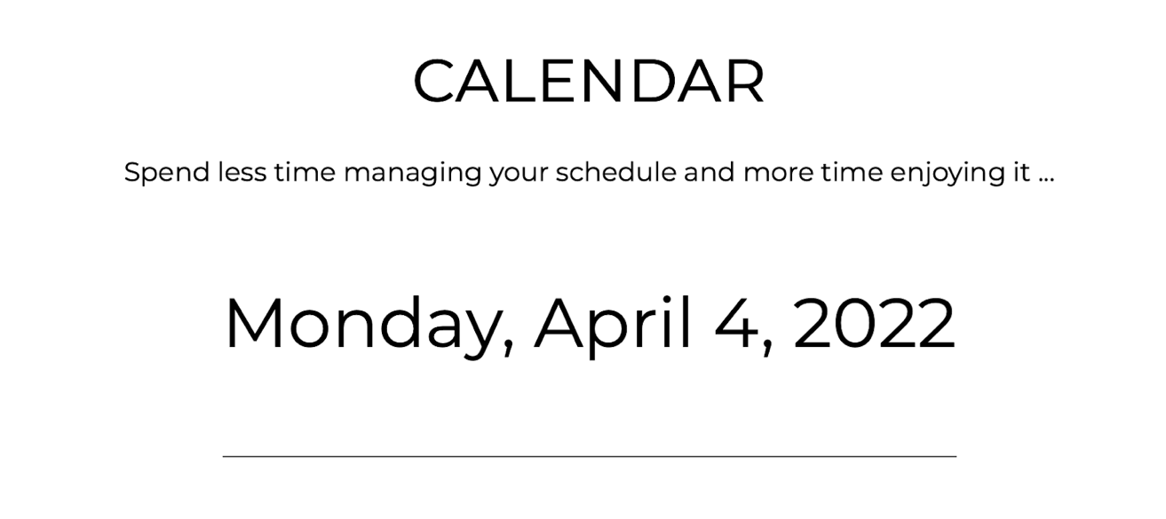

The **current date** and **day** is displayed in the header section of the calendar page as shown above.

**Week View of Calendar**

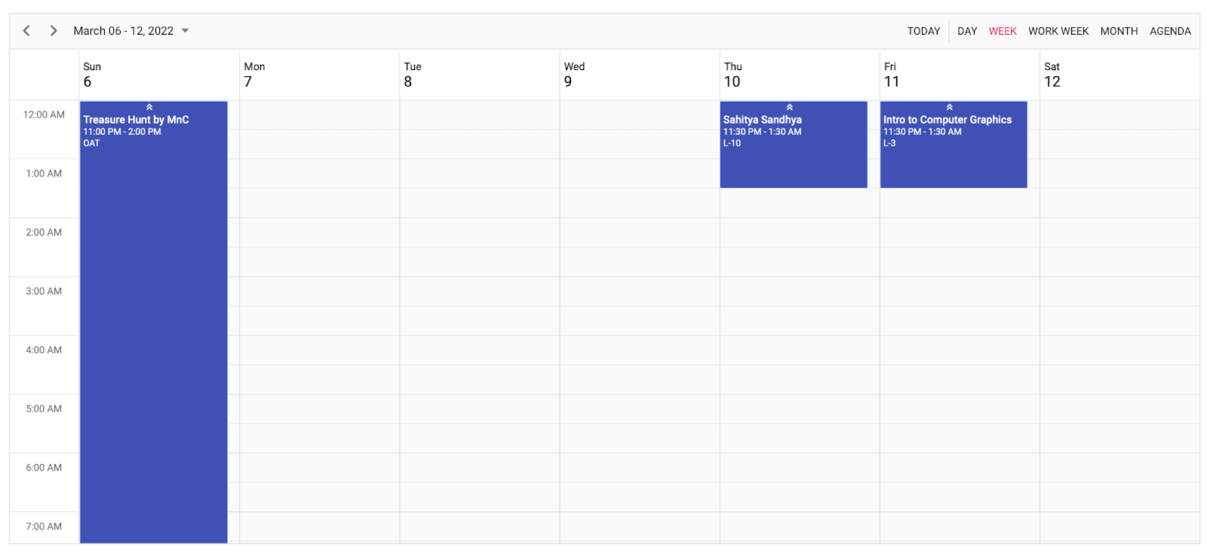

The figure shown above shows the weekly view of the events added in the calendar. The user can choose how to view the events -

1. Day-wise
2. Week-wise
3. Work Week-wise (excluding Saturday and Sunday)
4. Month-wise

**Monthly View of Calendar**

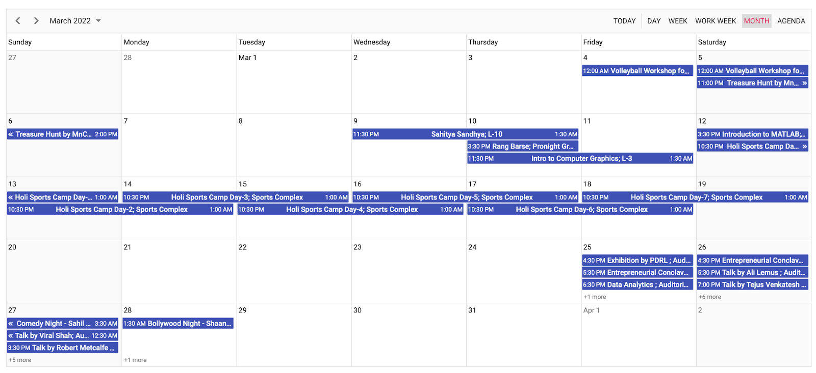

**Agenda**

This shows the list of all the events in a nutshell.

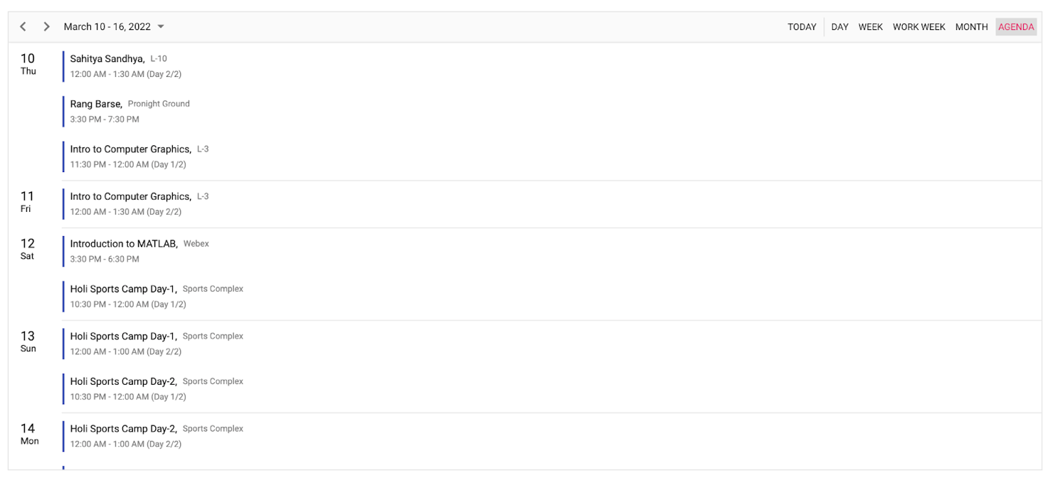

We have also added a **search** option to allow the users to find an event easily either by title, location, start time or end time.

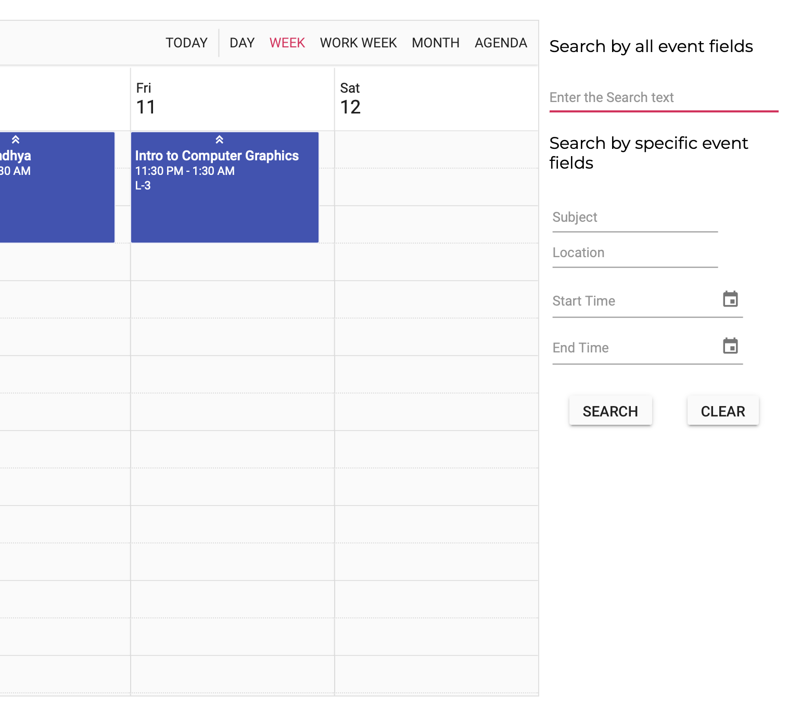

The search results will be visible as shown below -

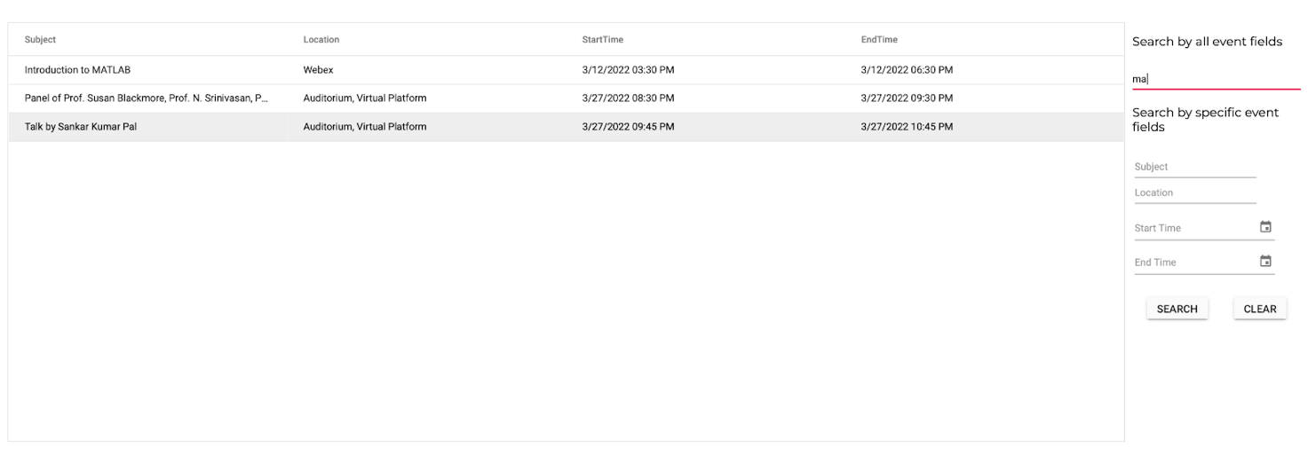

Now coming to the user and admin privileges -

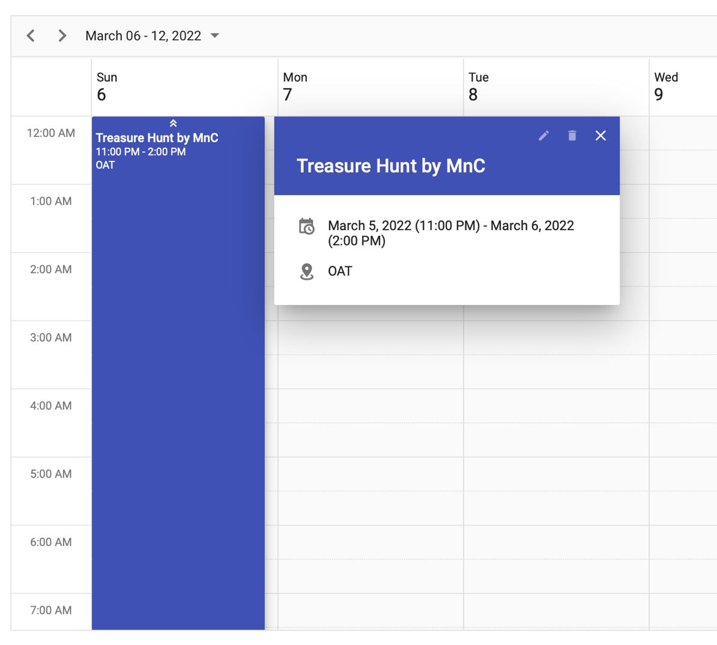

As you can see, when the user is a **guest** or a “**general**” user, the edit and delete option is disabled. They also cannot add any new events.

Now let’s see what the same features looks when we are logged in as an **Admin** -

As seen from the figure below, the “**edit**” and “**delete**” option is now enabled for the Admin. Thus, the admin is free to edit an event, delete an event or add a new event.

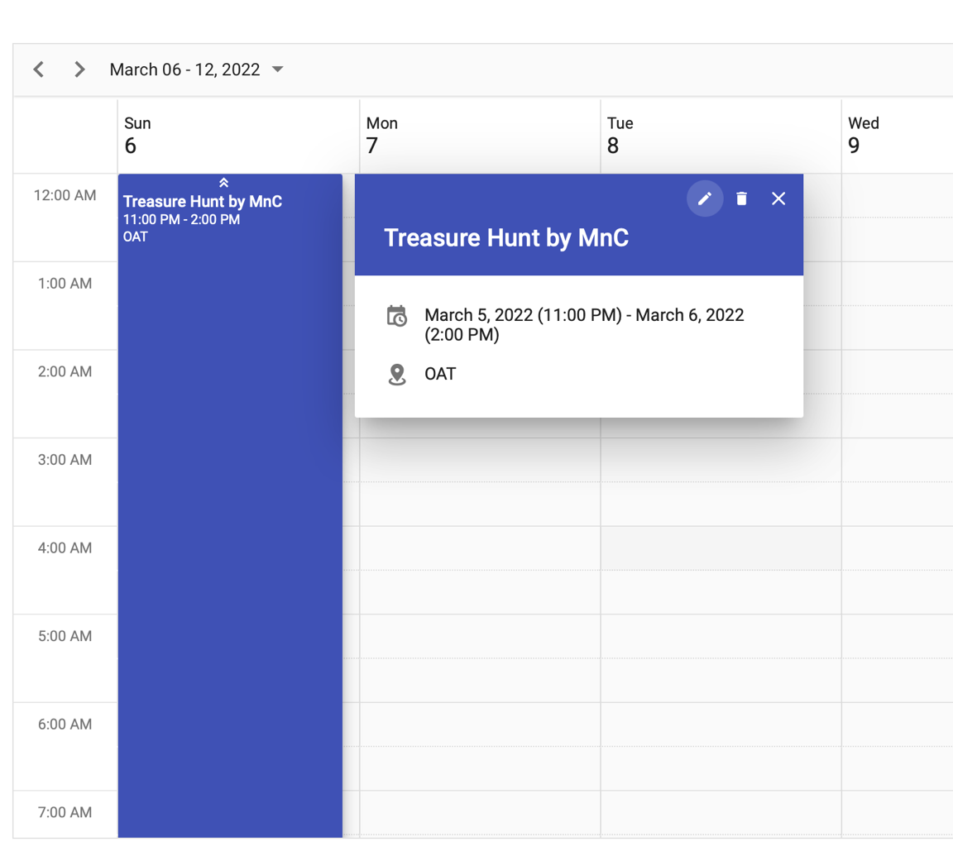

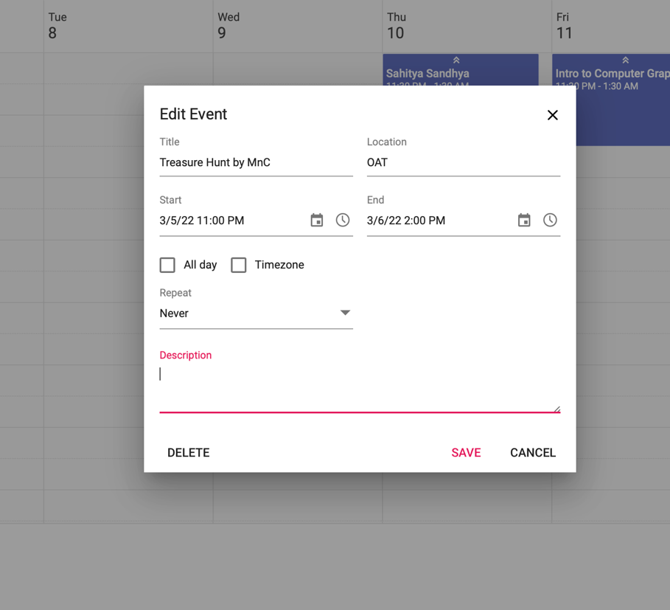

The Admin can change the time zone, add description, increase the duration etc.

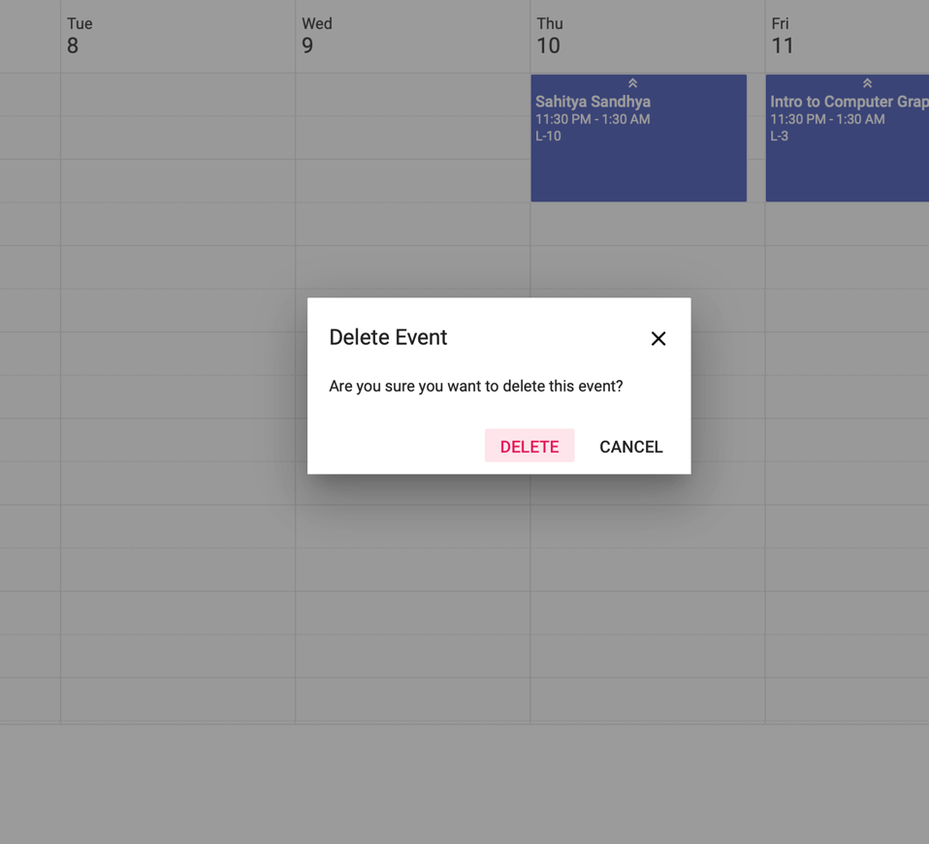

Admin can delete an event by clicking on the “Delete” button.

**Addition of New Events**

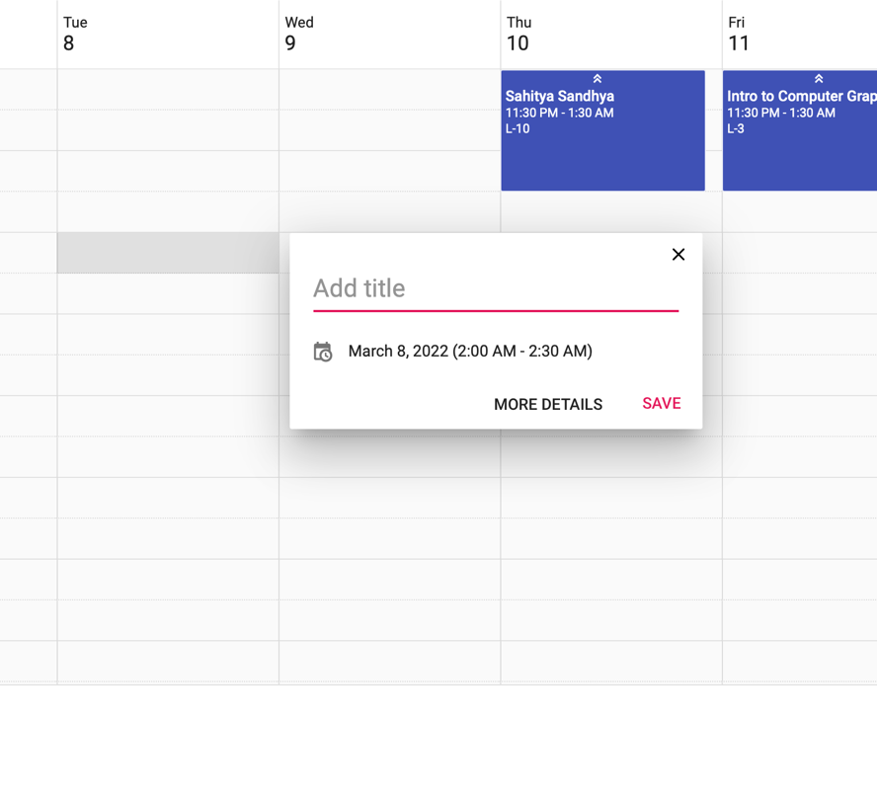

To simply add the title, the Admin can fill out the “Add Title” space. If the admin wants to add more details -

* Changing the duration of the event
* Whether the event is “All Day” or not
* Location of the event
* Repeat option (Daily, Weekly, Monthly etc.)
* Description of the event

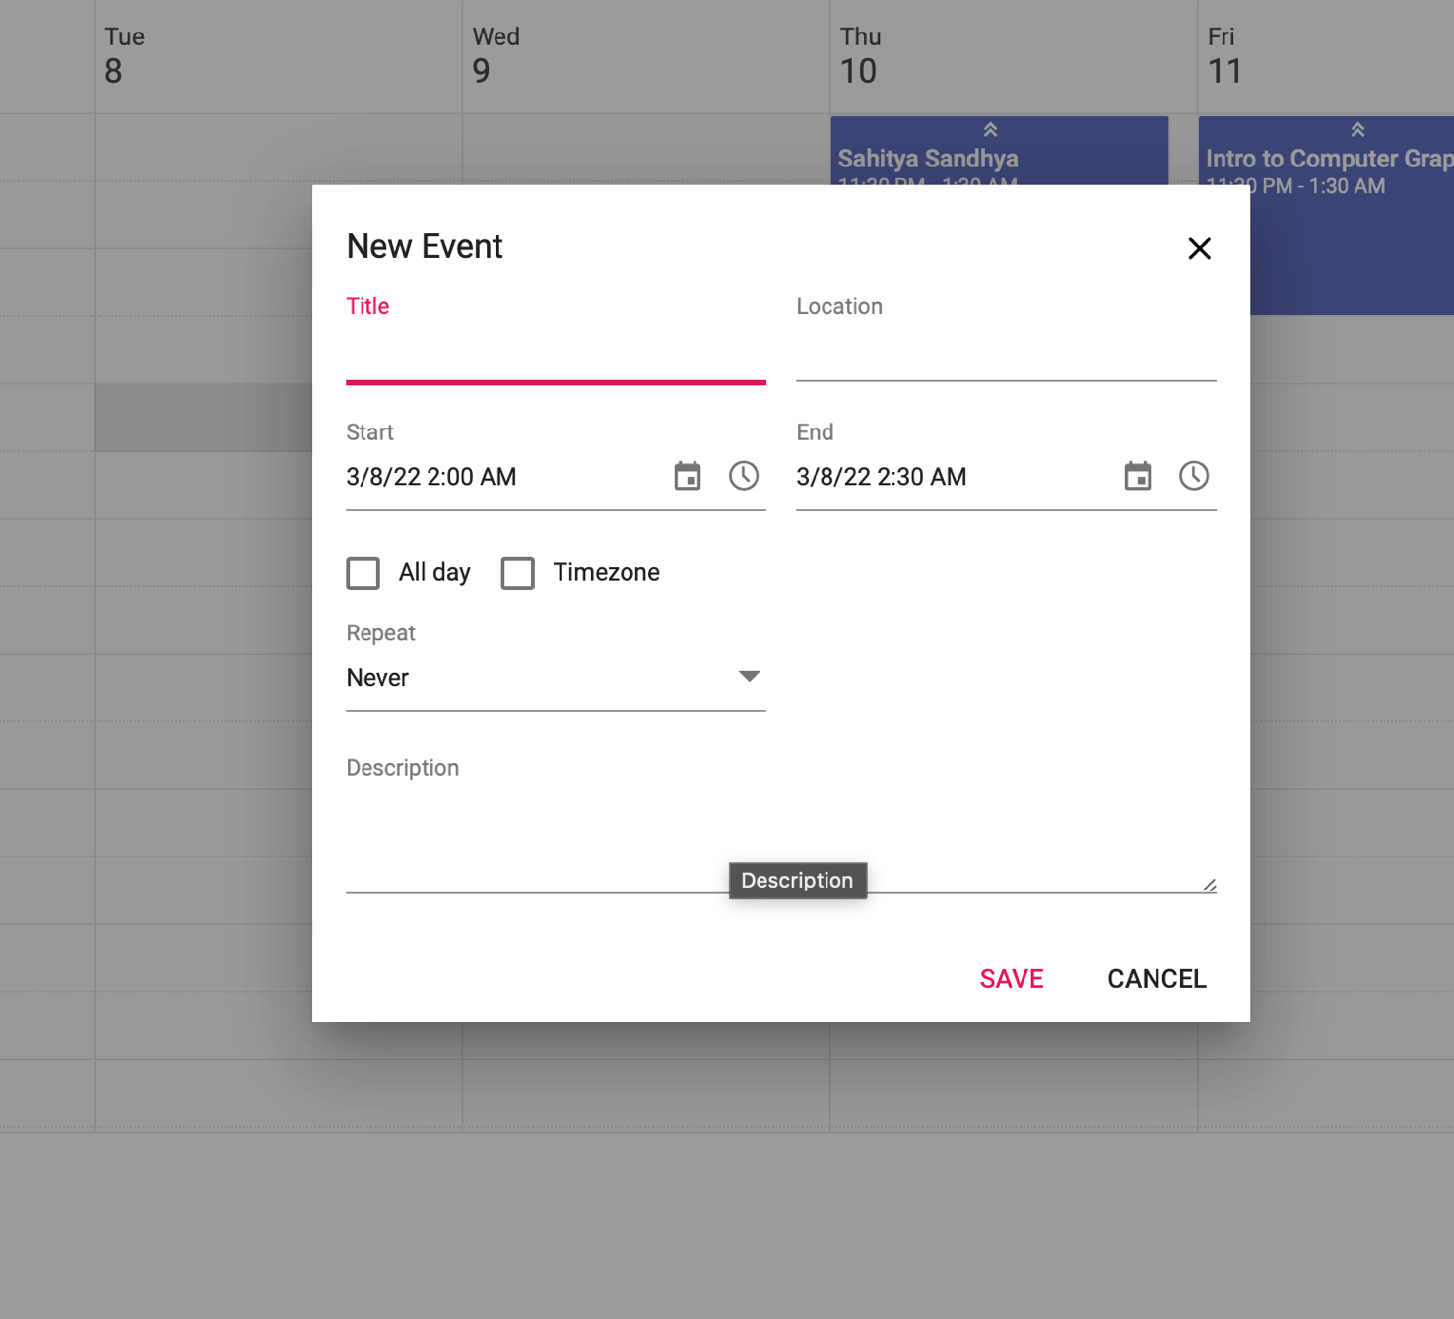

# Exploring the Councils and Festivals

**COUNCILS**

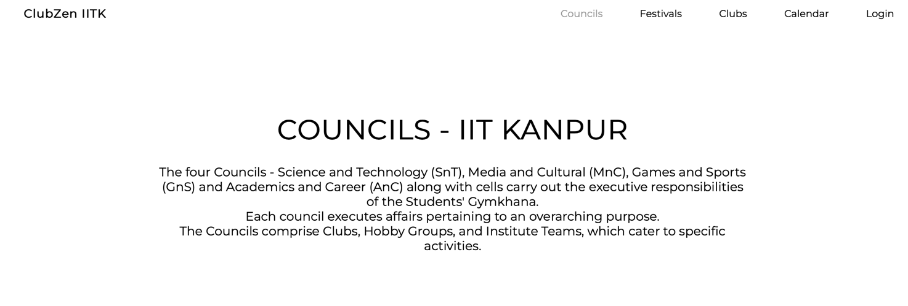

There are various pages which have been included in this web application like councils, festivals, and calendar which can be accessed by simply clicking on the top right corner which is shown above by the arrow.

**Science and technology (SnT)  council**

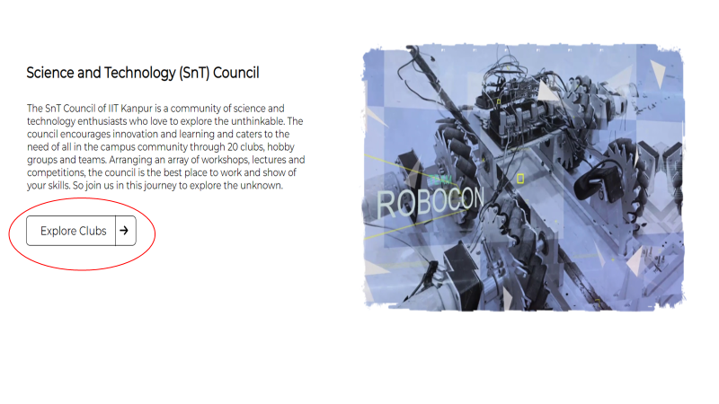

**Media and Cultural(MnC) Council**

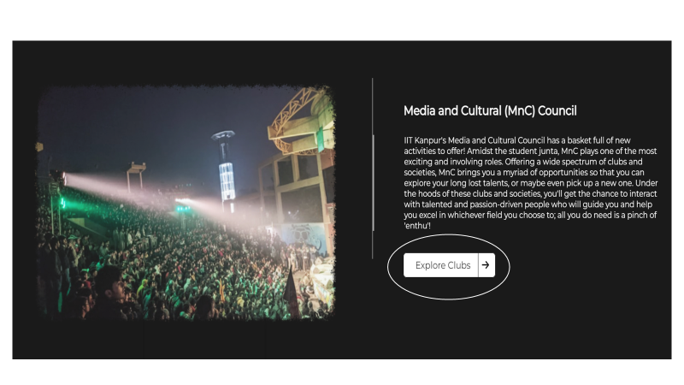

**Games and sports(GnS) Council**

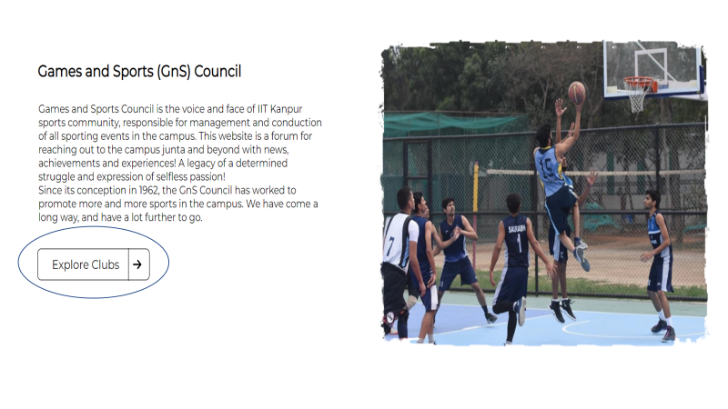

SnT, MnC, GnS are the three councils of IITK, their page can be found under the **Councils** section of ClubZen.

To know more about the clubs which come under these you can go to the **Explore Clubs** option.

**FESTIVALS**

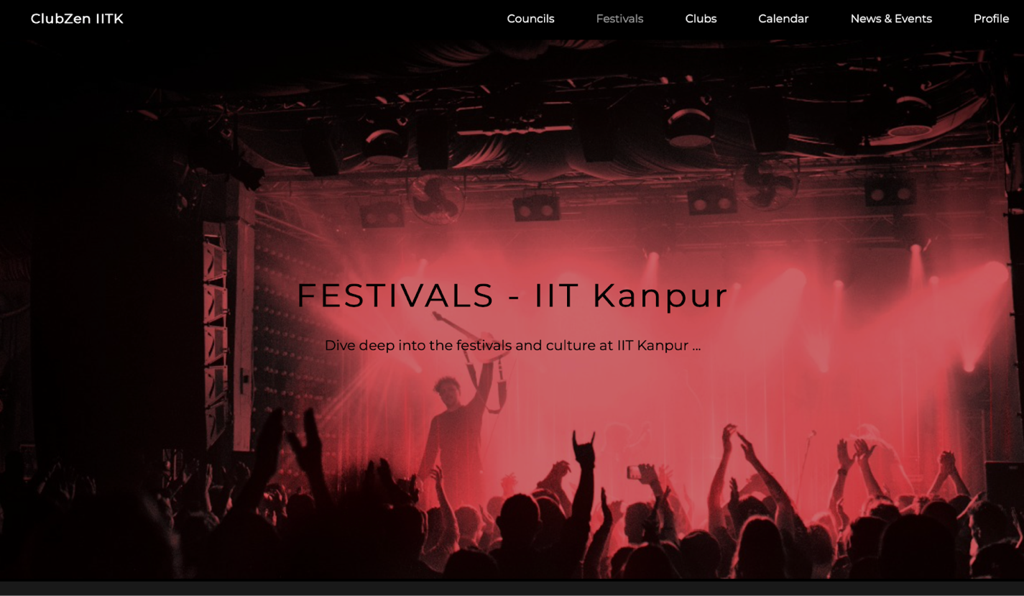

There are many festivals and fests in IIT Kanpur which are organized every year.

As the fests are an important part of the institute there’s a separate page for it. It can be found under the **Festivals** section in the top right corner.

We’ve included 3 main tests of IITK in this section which are Antaragni, Udghosh and Techkrirti.

**Antaragni**

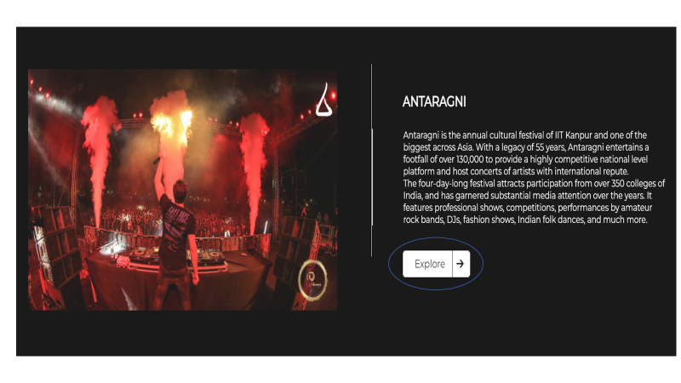

Antaragni is the annual cultural festival of IIT Kanpur and one of the biggest across Asia.It’s a four-day-long festival in which various events and activities are being organized.

The information regarding all of that can be found in this section by clicking on the **Explore** button.

**Udghosh**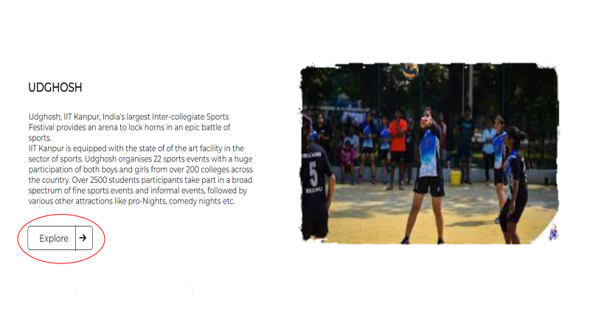

Udghosh is India’s largest inter-collegiate Sports Festival of IIT kanpur.

Over 2500 students from colleges all over India participate in this festival. Various sports events and other attractions like pro-Nights, comedy nights are organized under this. All the information about these can be found by clicking on the **Explore** button of this page.

**Techkriti**



Techkriti is an annual four-day-long inter-collegiate technical and entrepreneurship festival of IIT Kanpur. Various events like tech talks, pronite, and comedy night are held under this. All the information about these can be found by clicking on the **Explore** button of this page.

# Exploring Clubs

College is a great place to explore new opportunities and see what activities might interest you through clubs and extracurricular organizations.

This page will show all the clubs in all the three councils SnT , MnC, GnS.



On opening a particular club page it will be shown like this, a video demonstration is shown below :



This part of the page will show the gallery containing images of different activities that the club wants to post:  
  
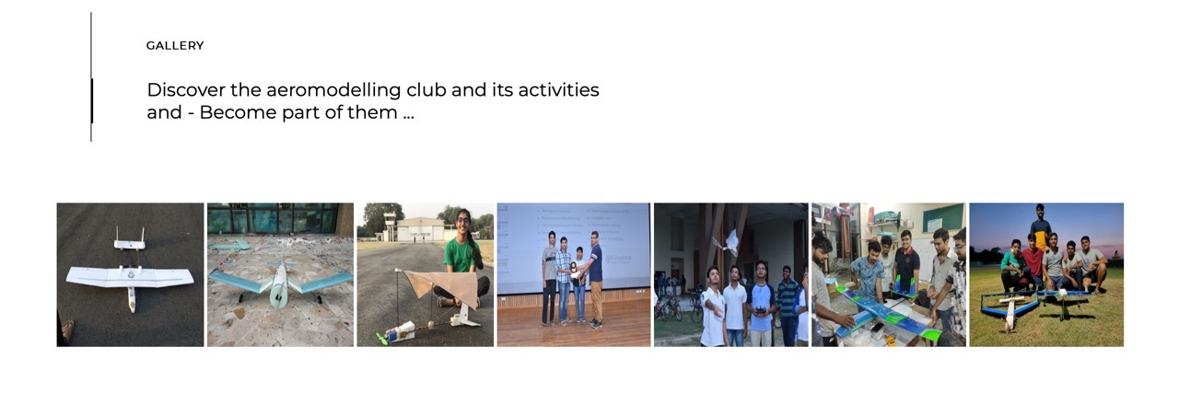

A video demonstration of gallery part is shown below:



This part of the club page will show the contact details and names of the team coordinators:

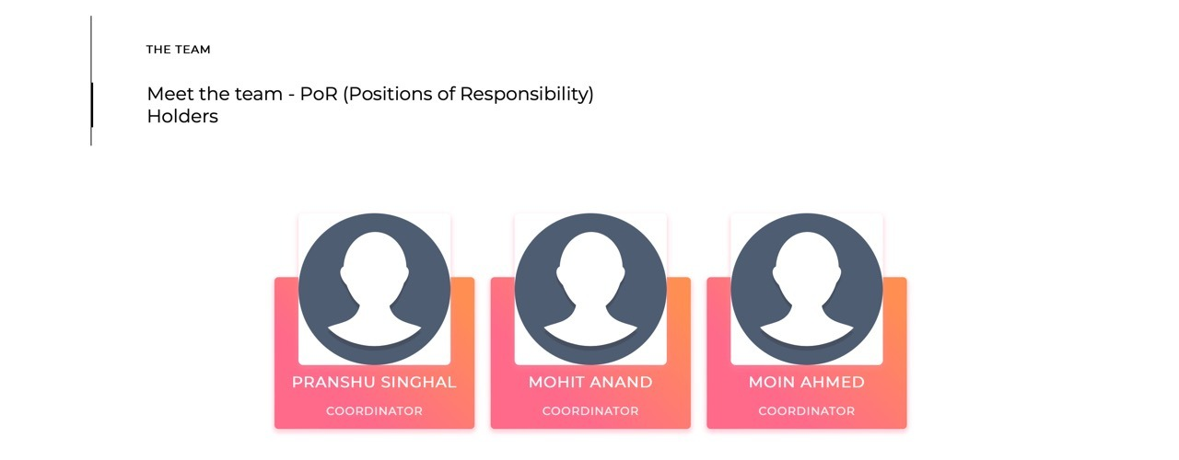

# News and Events

Through the **News and Events** page, the user will be able to get the latest news about various kinds of clubs, fests, news, events and workshops happening around campus.

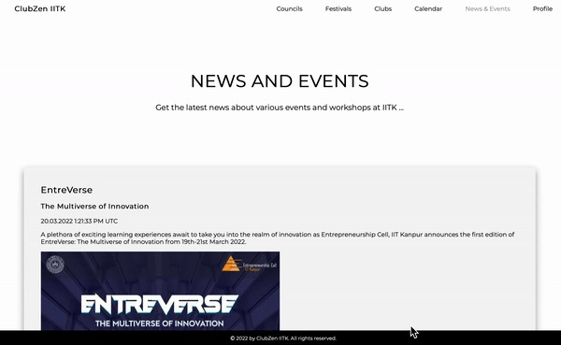

The news will be sectioned one below the other and all the information (like name of the event, the club organizing the event, etc.) related to the event will be available along with a short description. An official poster (if available) of the respective event will be featured as well.

